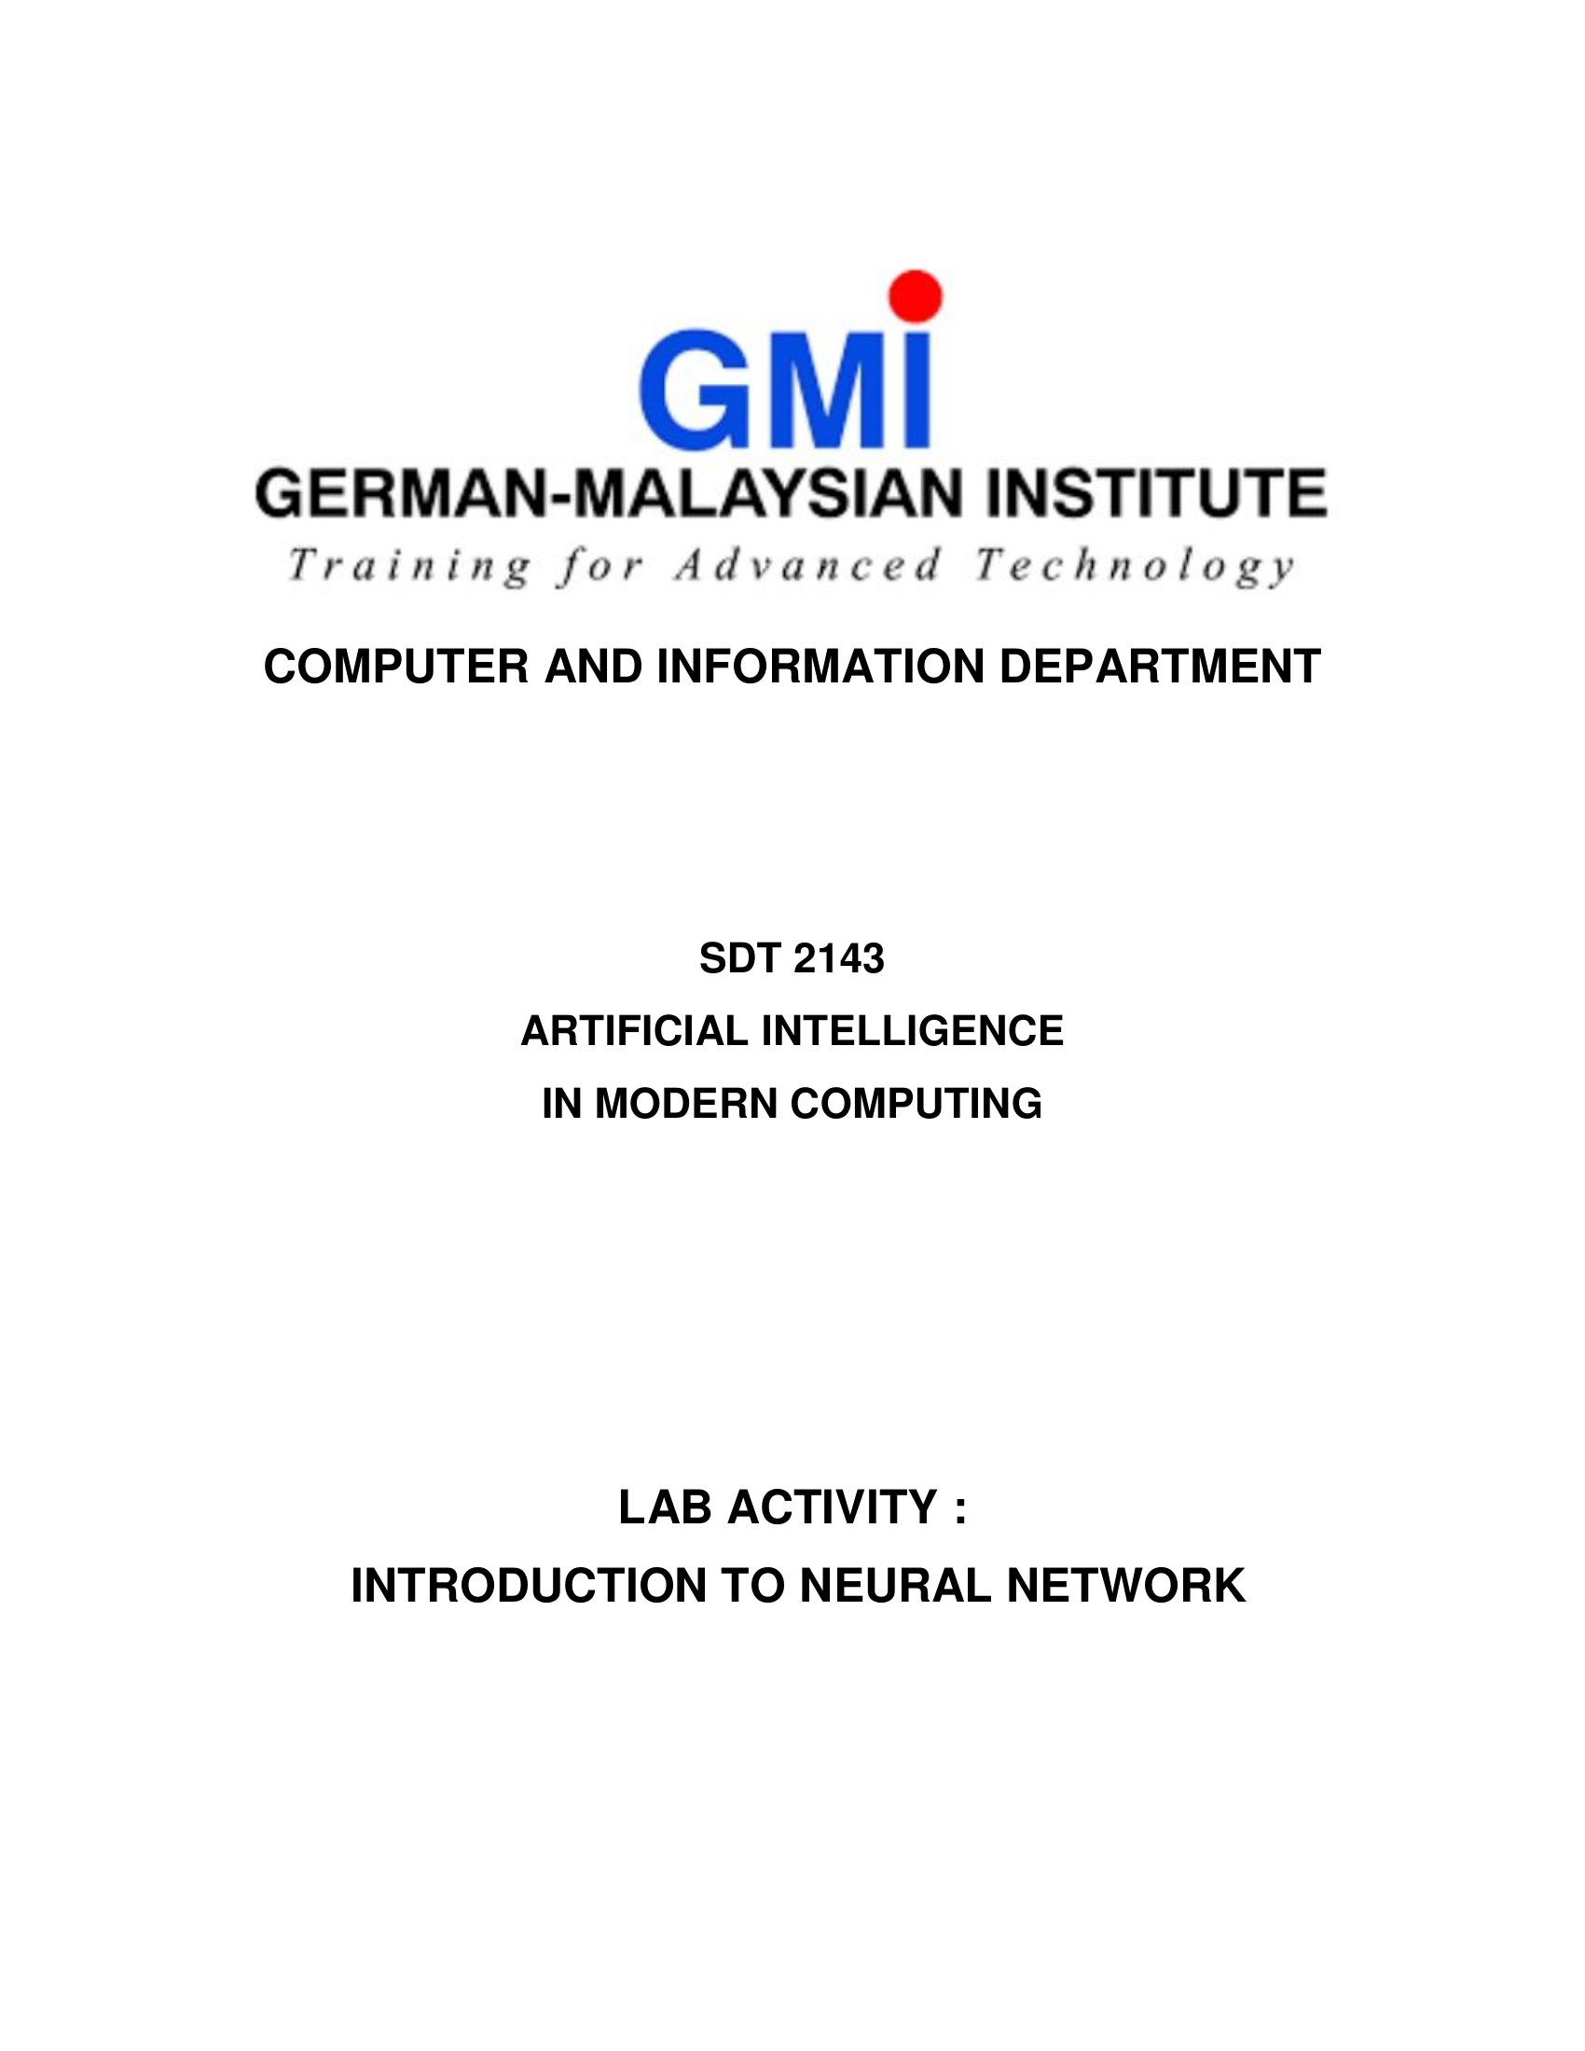



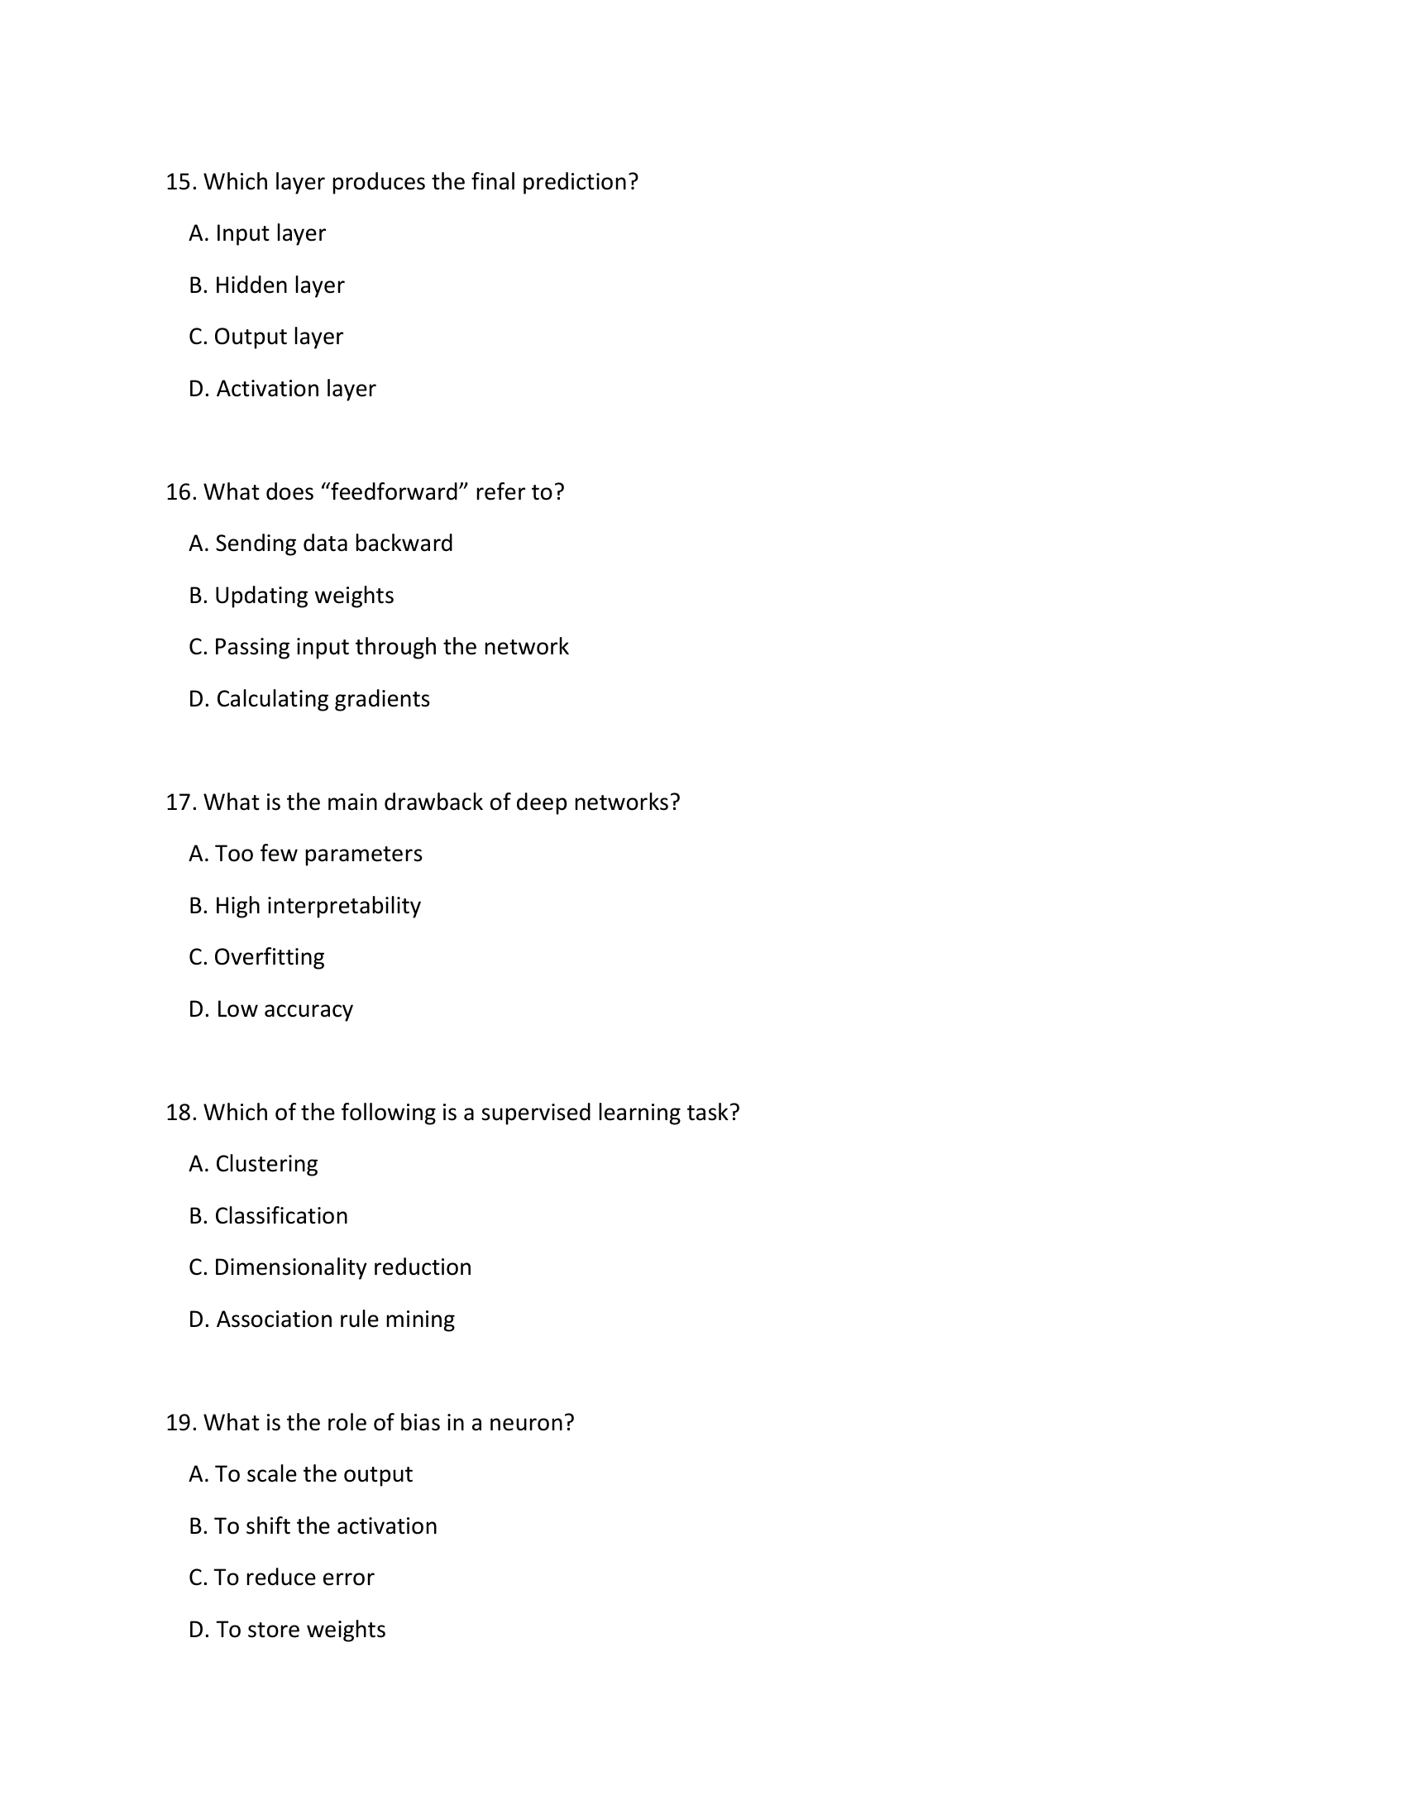


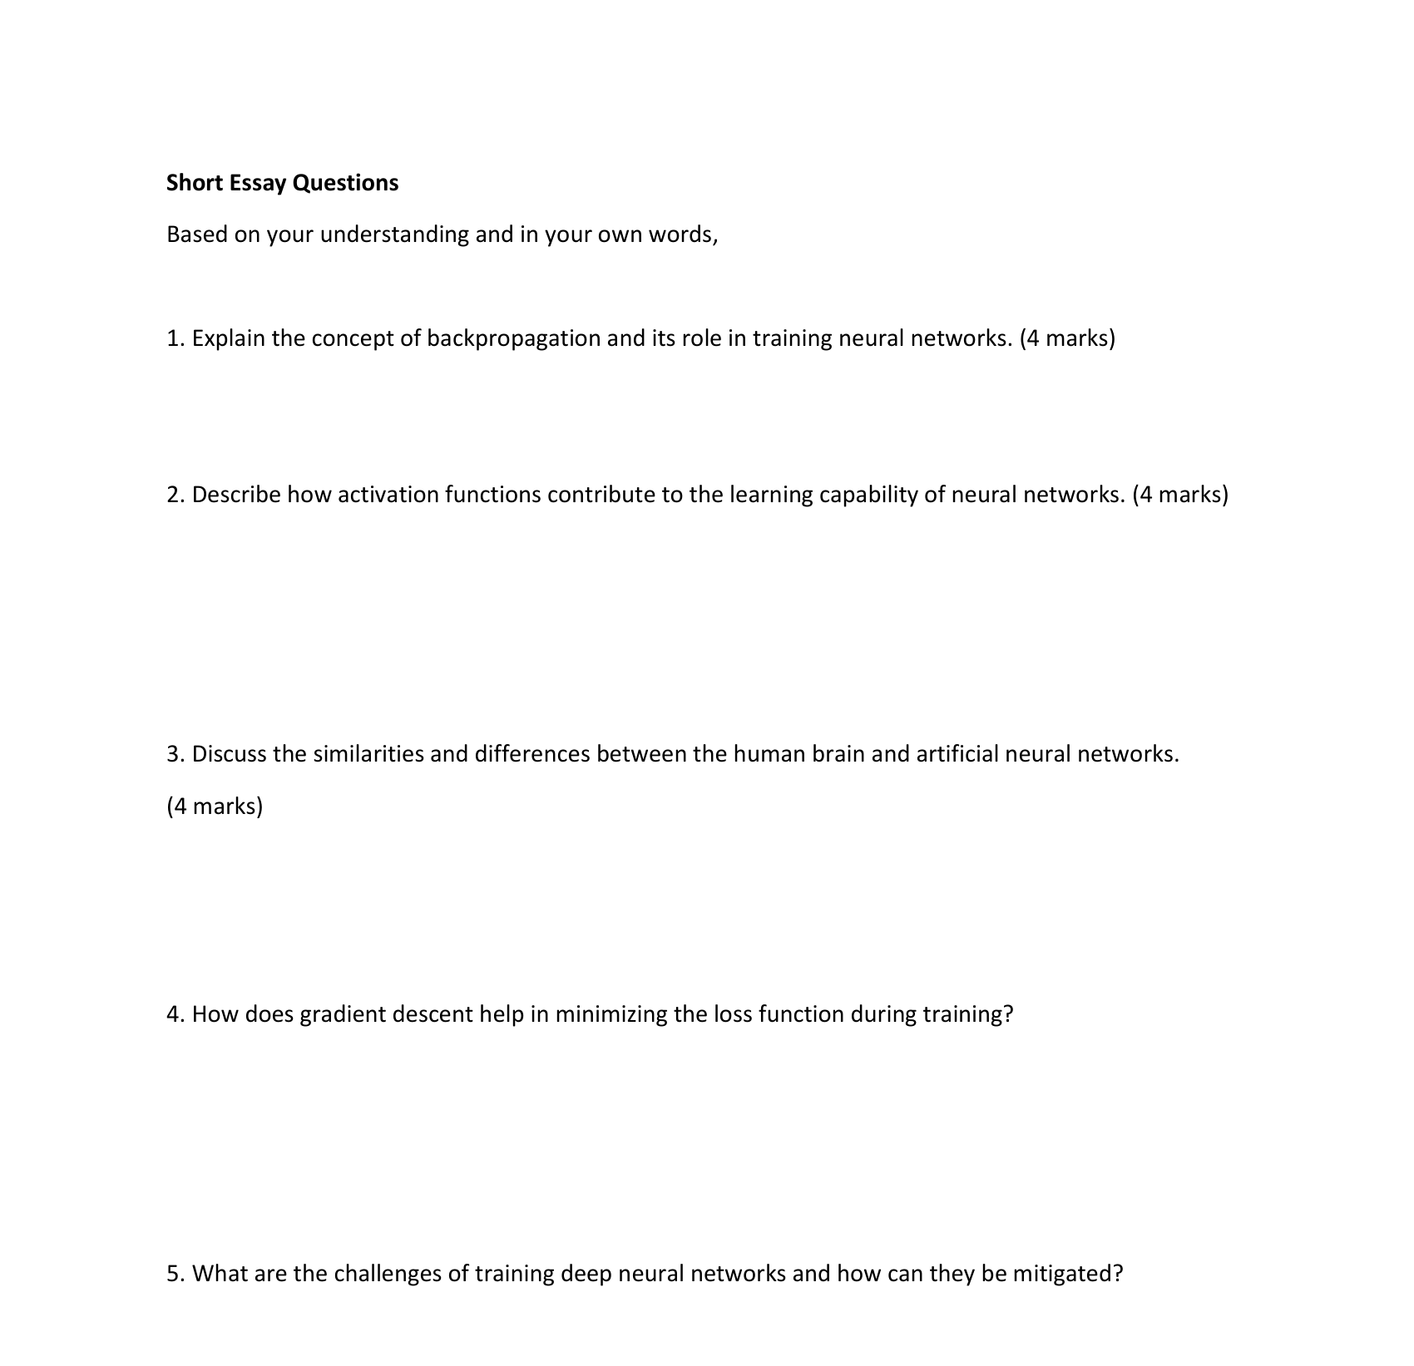

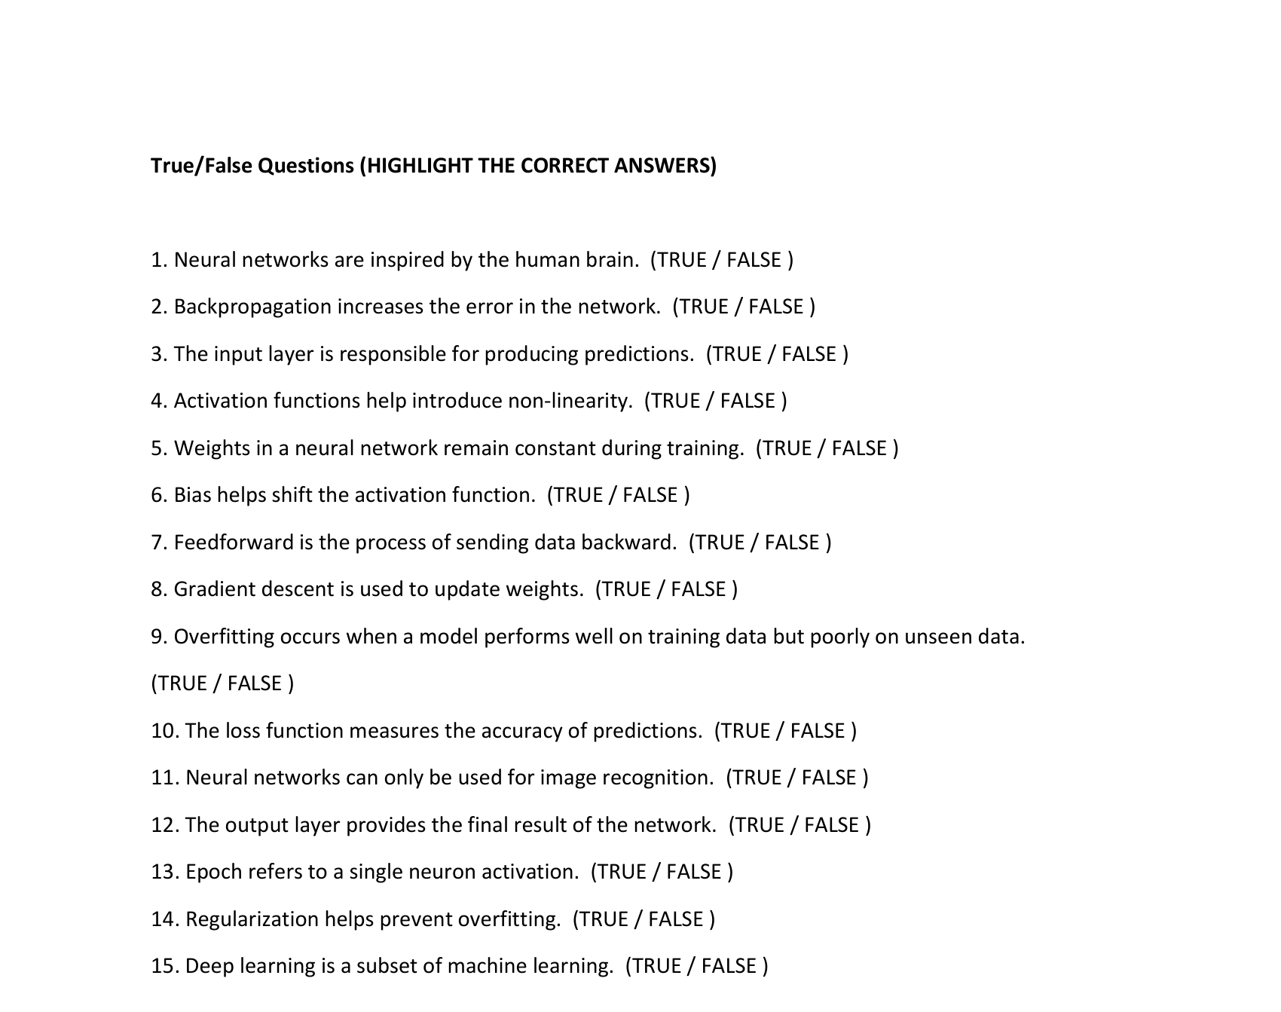

Multiple Choice Questions
- A. Neuron
- C. Weights
- D. Parameter values
- B. Activation function
- B. To calculate error
- C. Gradient descent
- B. Human brain
- C. Input layer
- B. Activation
- D. Linear regression
- B. To perform computations
- A. One complete pass through the dataset
- C. Regularization
- B. To update weights
- C. Output layer
- C. Passing input through the network
- C. Overfitting
- B. Classification
- B. To shift the activation
- B. Machine Learning

- Backpropagation is the core algorithm for training neural networks. It works in two main steps: first, data is passed forward through the network to make a prediction and calculate the error (loss). Then, this error is propagated backward from the output layer to the input layer. During this backward pass, the algorithm calculates the gradient of the loss function with respect to each weight and bias in the network using the chain rule of calculus. These gradients indicate how much each parameter contributed to the final error, allowing an optimization algorithm like gradient descent to make precise adjustments to minimize the loss in the next iteration.

- Activation functions are crucial because they introduce non-linearity into the network. Without them, a neural network would simply be a stack of linear transformations, no more powerful than a single linear model. Non-linear functions like Sigmoid, Tanh, and ReLU allow the network to learn and represent complex, real-world patterns and relationships beyond simple straight lines. They decide whether a neuron should be activate or not, enabling the network to build a complex mapping between inputs and outputs, which is essential for tasks like image recognition and language processing.

Aspect | Human Brain | Artificial Neural Networks
Basic Unit & Structure | Network of biological neurons. | Network of artificial neurons (nodes).
Learning Mechanism | Learns by strengthening synaptic connections. | Learns by adjusting numerical weights between nodes.
Processing & Capability | General, common-sense, and unsupervised learning. | Specialized, requires large data, excels at specific tasks.
Efficiency & Operation | Highly energy-efficient and parallel. | Computationally intensive and typically digital.

- Gradient descent minimizes the loss function by iteratively adjusting the model's parameters (weights and biases). It calculates the gradient (the slope) of the loss function at the current parameter values. Since the gradient points in the direction of the steepest ascent, gradient descent moves the parameters in the opposite direction (downhill) by a small step called the learning rate. This process is repeated, gradually descending the loss landscape until a (hopefully) minimum value is reached.

- Challenges:
  - Vanishing/Exploding Gradients: Gradients become extremely small or large as they are backpropagated through many layers, halting learning.
  - Overfitting: The model memorizes the training data and fails to generalize to new data.
  - Computational Cost: Deep networks require significant processing power and time to train.
  - Mitigation:
  - Using activation functions like ReLU and techniques like Batch Normalization to combat vanishing gradients.
  - Applying Regularization methods (e.g., L1/L2, Dropout) to prevent overfitting.
  - Using powerful hardware (GPUs/TPUs) and optimized libraries to handle computational demands.

True/False Questions
- TRUE
- FALSE
- FALSE
- TRUE
- FALSE
- TRUE
- FALSE
- TRUE
- TRUE
- FALSE
- FALSE
- TRUE
- FALSE
- TRUE
- TRUE

